1 run...

Downloading: 100%

411/411 [00:00<00:00, 11.4kB/s]

Downloading: 100%

263M/263M [00:10<00:00, 28.6MB/s]

training 1 epoch...

1344.5789155960083 seconds used......

1 training finished! average train loss: 0.8531419992272106

total clf loss: 537.5818801932037 total adv loss: 313.0519038066268

evaluating...

Confusion matrix, without normalization

[[ 336 364 322]

[ 159 5015 233]

[ 103 357 10305]]

Normalized confusion matrix

[[0.32876712 0.35616438 0.31506849]

[0.02940633 0.92750139 0.04309229]

[0.00956804 0.03316303 0.95726893]]

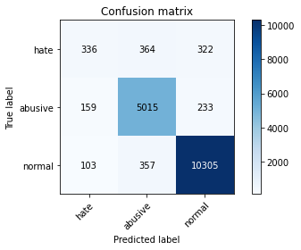

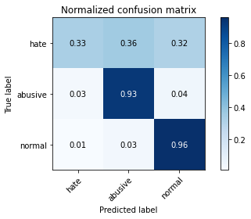

precision recall f1-score support

hate 0.56 0.33 0.41 1022

abusive 0.87 0.93 0.90 5407

normal 0.95 0.96 0.95 10765

accuracy 0.91 17194

macro avg 0.80 0.74 0.76 17194

weighted avg 0.90 0.91 0.90 17194

average eval_loss: 0.29030353727122377, accuracy: 0.9105501919274165

training 2 epoch...

1346.2291250228882 seconds used......

2 training finished! average train loss: 0.671369167085726

total clf loss: 424.82238960266113 total adv loss: 245.46257717628032

evaluating...

Confusion matrix, without normalization

[[ 501 287 234]

[ 327 4922 158]

[ 387 420 9958]]

Normalized confusion matrix

[[0.49021526 0.28082192 0.22896282]

[0.06047716 0.91030146 0.02922138]

[0.03594984 0.03901533 0.92503484]]

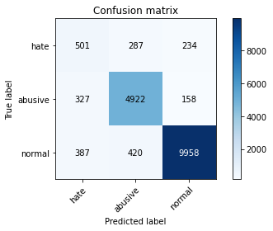

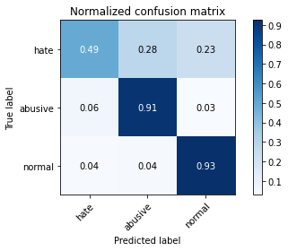

precision recall f1-score support

hate 0.41 0.49 0.45 1022

abusive 0.87 0.91 0.89 5407

normal 0.96 0.93 0.94 10765

accuracy 0.89 17194

macro avg 0.75 0.78 0.76 17194

weighted avg 0.90 0.89 0.90 17194

average eval_loss: 0.3141927543940932, accuracy: 0.8945562405490287

training 3 epoch...

1344.784607887268 seconds used......

3 training finished! average train loss: 0.5511546496252728

total clf loss: 348.2611230351031 total adv loss: 201.75691018579528

evaluating...

Confusion matrix, without normalization

[[ 490 276 256]

[ 376 4831 200]

[ 336 362 10067]]

Normalized confusion matrix

[[0.47945205 0.27005871 0.25048924]

[0.06953949 0.89347143 0.03698909]

[0.03121226 0.0336275 0.93516024]]

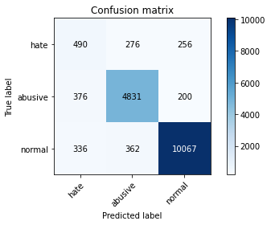

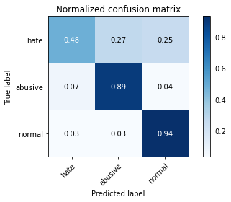

precision recall f1-score support

hate 0.41 0.48 0.44 1022

abusive 0.88 0.89 0.89 5407

normal 0.96 0.94 0.95 10765

accuracy 0.89 17194

macro avg 0.75 0.77 0.76 17194

weighted avg 0.90 0.89 0.90 17194

average eval_loss: 0.3187584211854914, accuracy: 0.8949633593113877

training 4 epoch...

1343.2157056331635 seconds used......

4 training finished! average train loss: 0.4348094157234129

total clf loss: 270.4841134897433 total adv loss: 161.29796482424717

evaluating...

Confusion matrix, without normalization

[[ 459 301 262]

[ 330 4862 215]

[ 361 377 10027]]

Normalized confusion matrix

[[0.44911937 0.29452055 0.25636008]

[0.061032 0.89920473 0.03976327]

[0.0335346 0.0350209 0.9314445 ]]

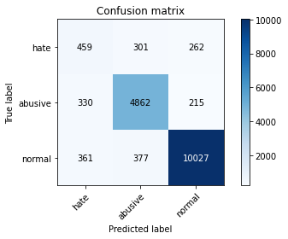

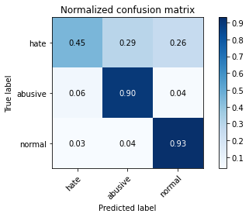

precision recall f1-score support

hate 0.40 0.45 0.42 1022

abusive 0.88 0.90 0.89 5407

normal 0.95 0.93 0.94 10765

accuracy 0.89 17194

macro avg 0.74 0.76 0.75 17194

weighted avg 0.90 0.89 0.89 17194

average eval_loss: 0.36576735804203986, accuracy: 0.8926369663836222

training 5 epoch...

1343.300768852234 seconds used......

5 training finished! average train loss: 0.34510512267583515

total clf loss: 208.86374892201275 total adv loss: 130.92981954384595

evaluating...

Confusion matrix, without normalization

[[ 406 341 275]

[ 277 4903 227]

[ 382 366 10017]]

Normalized confusion matrix

[[0.39726027 0.33365949 0.26908023]

[0.05122989 0.9067875 0.04198262]

[0.03548537 0.03399907 0.93051556]]

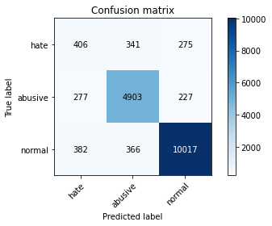

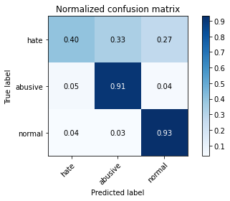

precision recall f1-score support

hate 0.38 0.40 0.39 1022

abusive 0.87 0.91 0.89 5407

normal 0.95 0.93 0.94 10765

accuracy 0.89 17194

macro avg 0.74 0.74 0.74 17194

weighted avg 0.89 0.89 0.89 17194

average eval_loss: 0.40516819757745104, accuracy: 0.8913574502733511

2 run...

training 1 epoch...

1344.8387715816498 seconds used......

1 training finished! average train loss: 0.8431720731676149

total clf loss: 536.8283884525299 total adv loss: 306.6291598584503

evaluating...

Confusion matrix, without normalization

[[ 334 418 270]

[ 95 5111 201]

[ 247 407 10111]]

Normalized confusion matrix

[[0.32681018 0.40900196 0.26418787]

[0.01756982 0.94525615 0.03717403]

[0.02294473 0.03780771 0.93924756]]

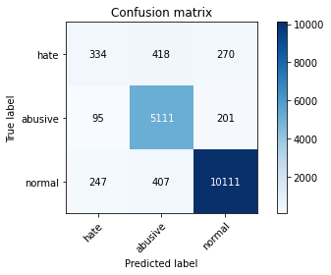

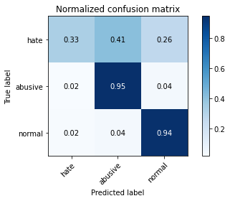

precision recall f1-score support

hate 0.49 0.33 0.39 1022

abusive 0.86 0.95 0.90 5407

normal 0.96 0.94 0.95 10765

accuracy 0.90 17194

macro avg 0.77 0.74 0.75 17194

weighted avg 0.90 0.90 0.90 17194

average eval_loss: 0.3079897514436134, accuracy: 0.9047342096080028

training 2 epoch...

1344.4976675510406 seconds used......

2 training finished! average train loss: 0.6813759495151882

total clf loss: 428.55831456556916 total adv loss: 250.4192408900708

evaluating...

Confusion matrix, without normalization

[[ 494 264 264]

[ 347 4858 202]

[ 337 355 10073]]

Normalized confusion matrix

[[0.48336595 0.25831703 0.25831703]

[0.06417607 0.89846495 0.03735898]

[0.03130516 0.03297724 0.9357176 ]]

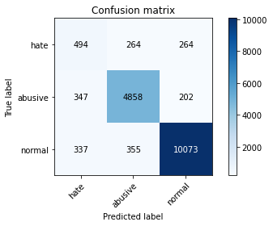

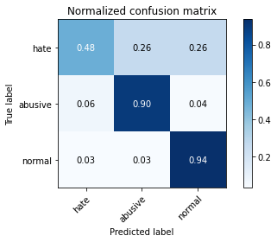

precision recall f1-score support

hate 0.42 0.48 0.45 1022

abusive 0.89 0.90 0.89 5407

normal 0.96 0.94 0.95 10765

accuracy 0.90 17194

macro avg 0.75 0.77 0.76 17194

weighted avg 0.90 0.90 0.90 17194

average eval_loss: 0.3086532318228206, accuracy: 0.8971152727695708

training 3 epoch...

1343.9557521343231 seconds used......

3 training finished! average train loss: 0.6040473230336069

total clf loss: 381.9057397134602 total adv loss: 221.0074041960761

evaluating...

Confusion matrix, without normalization

[[ 442 312 268]

[ 261 4942 204]

[ 282 434 10049]]

Normalized confusion matrix

[[0.43248532 0.30528376 0.26223092]

[0.04827076 0.91400037 0.03772887]

[0.02619601 0.04031584 0.93348816]]

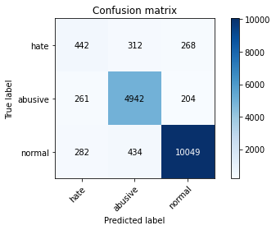

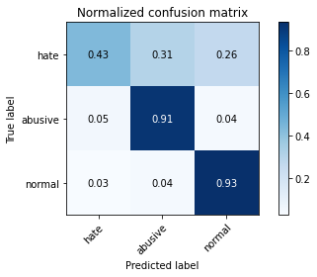

precision recall f1-score support

hate 0.45 0.43 0.44 1022

abusive 0.87 0.91 0.89 5407

normal 0.96 0.93 0.94 10765

accuracy 0.90 17194

macro avg 0.76 0.76 0.76 17194

weighted avg 0.90 0.90 0.90 17194

average eval_loss: 0.31211099396351466, accuracy: 0.8975805513551239

training 4 epoch...

1343.395973443985 seconds used......

4 training finished! average train loss: 0.5527874524691456

total clf loss: 344.12001378741115 total adv loss: 204.94103517010808

evaluating...

Confusion matrix, without normalization

[[ 386 342 294]

[ 209 4960 238]

[ 227 407 10131]]

Normalized confusion matrix

[[0.3776908 0.33463796 0.28767123]

[0.0386536 0.91732939 0.04401701]

[0.02108686 0.03780771 0.94110543]]

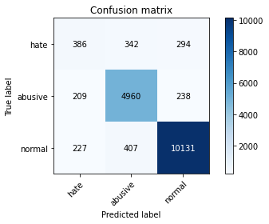

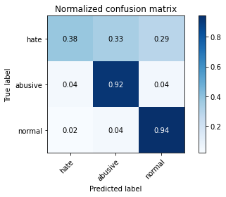

precision recall f1-score support

hate 0.47 0.38 0.42 1022

abusive 0.87 0.92 0.89 5407

normal 0.95 0.94 0.95 10765

accuracy 0.90 17194

macro avg 0.76 0.75 0.75 17194

weighted avg 0.90 0.90 0.90 17194

average eval_loss: 0.31850291293894134, accuracy: 0.9001395835756659

training 5 epoch...

1344.6513154506683 seconds used......

5 training finished! average train loss: 0.47026395907863167

total clf loss: 291.8313402021304 total adv loss: 174.80435029766522

evaluating...

Confusion matrix, without normalization

[[ 455 267 300]

[ 314 4754 339]

[ 253 304 10208]]

Normalized confusion matrix

[[0.44520548 0.26125245 0.29354207]

[0.05807287 0.87923063 0.0626965 ]

[0.02350209 0.02823967 0.94825824]]

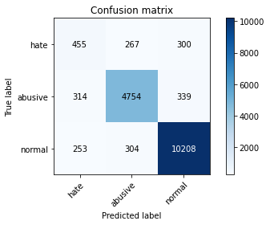

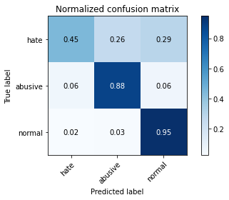

precision recall f1-score support

hate 0.45 0.45 0.45 1022

abusive 0.89 0.88 0.89 5407

normal 0.94 0.95 0.94 10765

accuracy 0.90 17194

macro avg 0.76 0.76 0.76 17194

weighted avg 0.90 0.90 0.90 17194

average eval_loss: 0.35444412511491846, accuracy: 0.8966499941840177

1 run...

Downloading: 100%

411/411 [00:00<00:00, 14.5kB/s]

Downloading: 100%

263M/263M [00:12<00:00, 23.3MB/s]

training 1 epoch...

1356.3925199508667 seconds used......

1 training finished! average train loss: 0.8374033752949007

total clf loss: 532.7698391675949 total adv loss: 304.7241822918877

evaluating...

Confusion matrix, without normalization

[[ 435 254 333]

[ 312 4831 264]

[ 118 309 10338]]

Normalized confusion matrix

[[0.42563601 0.24853229 0.3258317 ]

[0.05770298 0.89347143 0.0488256 ]

[0.01096145 0.02870413 0.96033442]]

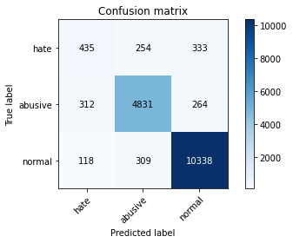

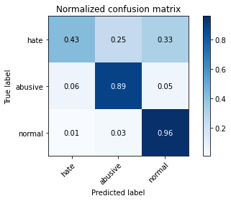

precision recall f1-score support

hate 0.50 0.43 0.46 1022

abusive 0.90 0.89 0.89 5407

normal 0.95 0.96 0.95 10765

accuracy 0.91 17194

macro avg 0.78 0.76 0.77 17194

weighted avg 0.90 0.91 0.91 17194

average eval_loss: 0.2831236955276582, accuracy: 0.9075258811213214

training 2 epoch...

1357.9938571453094 seconds used......

2 training finished! average train loss: 0.6615762254168605

total clf loss: 419.61455500870943 total adv loss: 241.38770860619843

evaluating...

Confusion matrix, without normalization

[[ 369 335 318]

[ 179 4991 237]

[ 129 351 10285]]

Normalized confusion matrix

[[0.36105675 0.32778865 0.3111546 ]

[0.03310523 0.9230627 0.04383207]

[0.01198328 0.03260567 0.95541105]]

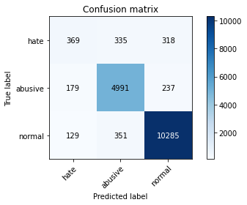

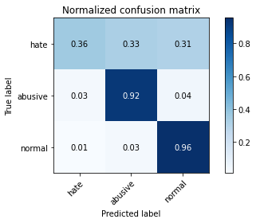

precision recall f1-score support

hate 0.55 0.36 0.43 1022

abusive 0.88 0.92 0.90 5407

normal 0.95 0.96 0.95 10765

accuracy 0.91 17194

macro avg 0.79 0.75 0.76 17194

weighted avg 0.90 0.91 0.91 17194

average eval_loss: 0.2795845392203435, accuracy: 0.909910433872281

training 3 epoch...

1357.9296214580536 seconds used......

3 training finished! average train loss: 0.5381590463118655

total clf loss: 342.07668255176395 total adv loss: 195.98612838741974

evaluating...

Confusion matrix, without normalization

[[ 394 333 295]

[ 224 4921 262]

[ 213 321 10231]]

Normalized confusion matrix

[[0.38551859 0.3258317 0.28864971]

[0.04142778 0.91011652 0.04845571]

[0.01978634 0.02981886 0.9503948 ]]

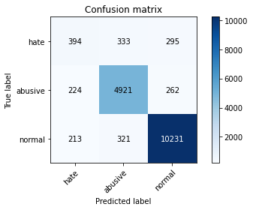

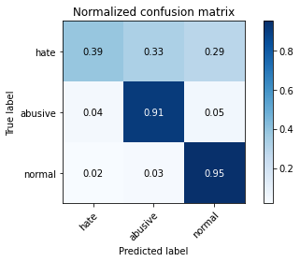

precision recall f1-score support

hate 0.47 0.39 0.43 1022

abusive 0.88 0.91 0.90 5407

normal 0.95 0.95 0.95 10765

accuracy 0.90 17194

macro avg 0.77 0.75 0.76 17194

weighted avg 0.90 0.90 0.90 17194

average eval_loss: 0.3067771069922073, accuracy: 0.9041526113760614

training 4 epoch...

1356.4788756370544 seconds used......

4 training finished! average train loss: 0.4107798624543413

total clf loss: 258.4519060924649 total adv loss: 150.9259132295847

evaluating...

Confusion matrix, without normalization

[[ 493 256 273]

[ 422 4729 256]

[ 429 306 10030]]

Normalized confusion matrix

[[0.48238748 0.25048924 0.26712329]

[0.07804698 0.87460699 0.04734603]

[0.03985137 0.02842545 0.93172318]]

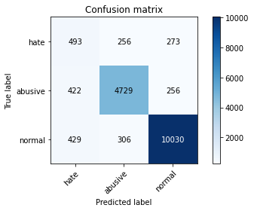

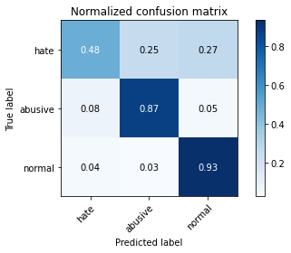

precision recall f1-score support

hate 0.37 0.48 0.42 1022

abusive 0.89 0.87 0.88 5407

normal 0.95 0.93 0.94 10765

accuracy 0.89 17194

macro avg 0.74 0.76 0.75 17194

weighted avg 0.90 0.89 0.89 17194

average eval_loss: 0.3815749730113461, accuracy: 0.887053623356985

training 5 epoch...

1356.681093454361 seconds used......

5 training finished! average train loss: 0.3105501958539114

total clf loss: 191.87507027667016 total adv loss: 115.85769846313633

evaluating...

Confusion matrix, without normalization

[[ 496 274 252]

[ 516 4685 206]

[ 560 310 9895]]

Normalized confusion matrix

[[0.4853229 0.26810176 0.24657534]

[0.09543185 0.86646939 0.03809876]

[0.05202044 0.02879703 0.91918254]]

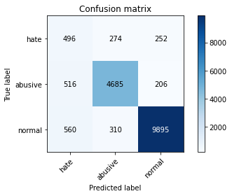

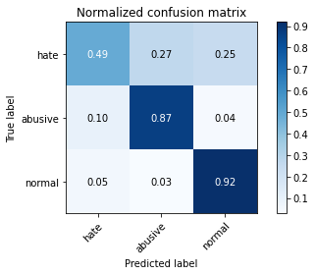

precision recall f1-score support

hate 0.32 0.49 0.38 1022

abusive 0.89 0.87 0.88 5407

normal 0.96 0.92 0.94 10765

accuracy 0.88 17194

macro avg 0.72 0.76 0.73 17194

weighted avg 0.90 0.88 0.89 17194

average eval_loss: 0.4484174542643433, accuracy: 0.8768174944748168

2 run...

training 1 epoch...

--